Heavy Rain (2010, Playstation 3), Quantic Dreams. GAMEPLAY

1. Composition
Tangible space | The entire surface of the screen.
Intangible space | On-screen action prompts that are regularly displayed
Negative Space | None
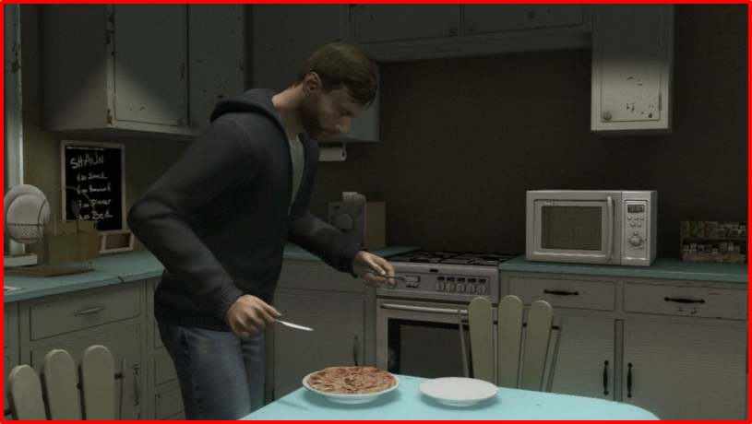

External | Zero Mimetic
2. Ocularization

3. Framing mechanisms | Anchor : Subjective | Mobility : Connected

4. Plane Analysis
 | Agents | In-game | Off-game
Graphical materials | Real-time polygons | Real-time polygons | Raster backdrops
Projection method | Linear projection | Linear projection | Linear projection
Angle of projection | Various | Various | Horizontal

Notes :
In Heavy Rain, the gameplay constantly switches between moments when the player-character is walking, with the in-game camera following along, and cut-scenes, when the player must react to Quick-Time Events (QTEs) by acting according to on-screen prompts. The latter moment is typical of QTE-driven FMV games such as Dragon’s Lair.

These two moments could be distinguished as two separate visual modes, but in pragmatic terms, the gameplay experience presents these moments as seamless transitions, so I consider them to be two facets of the same, single visual mode I call “gameplay”. Ocularization remains the same across both facets; even when the player-character is walking around, instead of lapsing into zero ergodic “transparent control”, there is still “camera work” going on with marked visual mediation, including spatial montage (triggering of alternate camera angles), variation in focus or depth of field, or panning.
